

TFB2063
DATA SCIENCE

ASSIGNMENT 2

SEMESTER JANUARY 2026

LECTURER:
DR. MAGED NASSER & AP DR. IBRAHIM VENKAT

NO | NAME | ID
1 | MUHAMMAD FIRMAN HAKIM BIN CHE RAMLEE | 22012176
2 | NUR FATHIAH AISHA BINTI RAMNIZA | 22011102
3 | EIASHIA CALIANA BINTI ZURAYUSMADY | 22010844
4 | NUR SHALILI AMIRA BINTI BADRUL HISHAM | 22011687
5 | NURDINI HUMAIRA BINTI SYAMSUL AMIR | 22011842
6 | NUR IZZATI BINTI ISMAIL | 22011757

1.0 Executive Summary
This study presents a data-driven predictive analytics system designed to transition JB Bank from broad marketing to a precision-targeted strategy. By analyzing 5,000 customer profiles using the k-Nearest Neighbors (k-NN) algorithm, we developed a model to identify liability customers most likely to convert into Personal Loan customers. Our rigorous pre-processing, including feature selection and normalization, ensured a peak accuracy of 96.50% and a sensitivity of 71.35% at k=3. This model offers a significant competitive advantage over the baseline 9.6% conversion rate by identifying high-impact triggers such as income and education.

2.0 Problem Scenario and Strategy
JB Bank’s current loan conversion rate of 9.6% indicates a need for more sophisticated target marketing. To optimize outreach, we devised a two-stage strategy to identify "Potential Predictors" and eliminate data "noise" that could degrade model performance.
- Logical Elimination: We removed ID and ZIP Code as they are non-predictive identifiers or geographic variables that do not contribute to financial behavior analysis.
- Multicollinearity Control: We identified a 0.99 correlation between Age and Experience. To prevent "double-counting" identical data, Experience was eliminated, keeping the model lean and mathematically stable.
- Empirical Justification: A Correlation Matrix (Figure 1) was used to prove the predictive power of remaining variables, highlighting Income (0.50) and CCAvg (0.37) as primary drivers of loan acceptance.
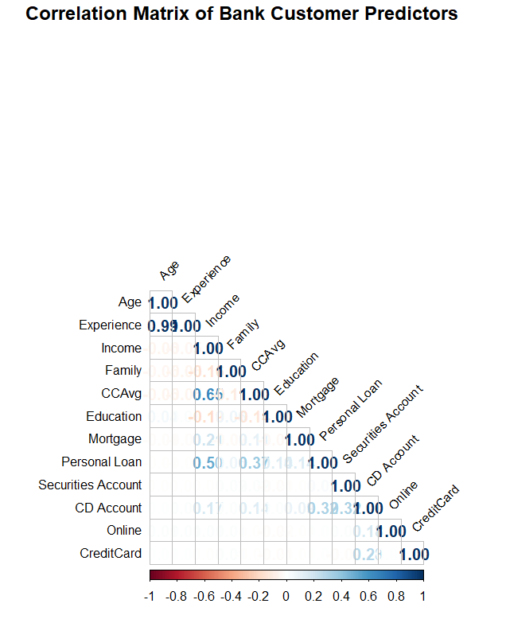
Figure 1:Correlation Matrix

The following code demonstrates our modular approach to data cleaning, ensuring that only significant attributes are passed to the k-NN algorithm:
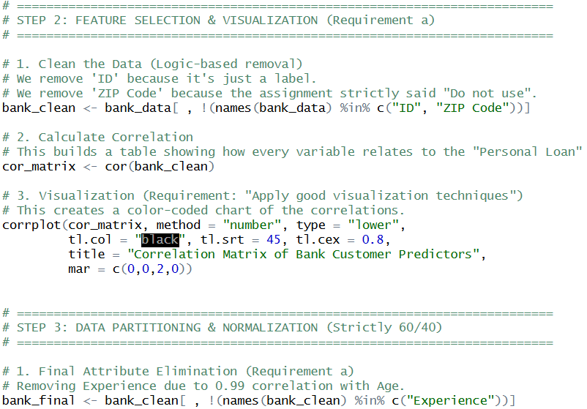

3.0 Methodology
The technical workflow for this study was initiated by partitioning the dataset to ensure the dependability and reproducibility of the model's predictions. To strictly test the performance of our models and identify the optimal k, we utilized a structured approach consisting of stratified sampling, Z-score normalization, and 10-fold cross-validation.

3.1 Data Partitioning (60/40 Split)
Following the assignment requirements, the record of 5,000 customers was partitioned using the createDataPartition function in R.
- Training Set (60%): Comprising 3,000 observations used to train the k-NN algorithm.
- Validation Set (40%): Comprising 2,000 observations used to evaluate the model's predictive power on unseen data.
- Stratified Sampling: We used stratified sampling to maintain the original 9.6% loan acceptance rate in both subsets. This ensures that the minority "Asset" customer group is sufficiently represented during both training and validation.
- Reproducibility: A set.seed(123) was applied before partitioning to ensure the results can be consistently replicated during the Q&A session.

3.2 Z-Score Normalization
Since k-NN is a distance-based algorithm, data standardization is essential. Our variables had vastly distinct scales, such as Income (ranging into the hundreds of thousands) and Education (on a 1-3 scale).
- Normalization Strategy: We applied Z-score Standardization to center and scale the data.
- Result: This ensures that all predictors carry equal weight in distance calculations, preventing high-range features from overshadowing lower-range variables.

3.3 Evaluation Mechanism: 10-Fold Cross-Validation
To provide an objective estimate of accuracy, we implemented 10-fold Cross-Validation.
- Process: The training data is split into 10 folds; the model is trained on 9 folds and validated on the remaining fold, repeating this process 10 times.
- Outcome: This methodology averages the results across all folds, providing a robust foundation for optimizing the $k$ parameter.

3.4 R Implementation: Methodology
This modular code block represents the implementation of the methodology described above:
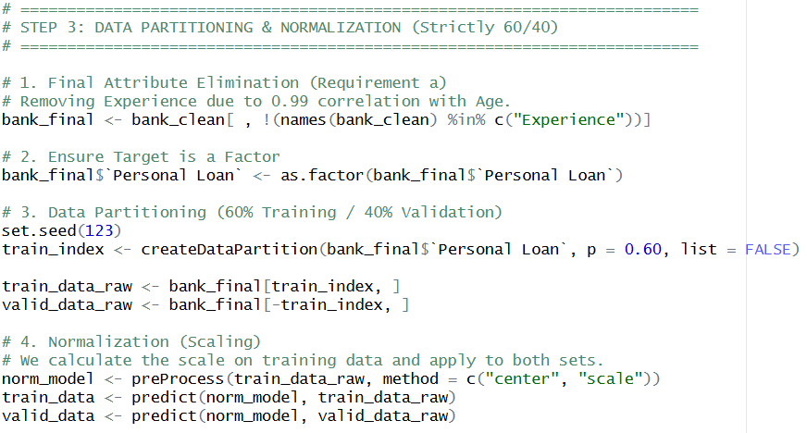

4.0 Empirical Justification of k
The effectiveness of the k-Nearest Neighbors (k-NN) algorithm depends on selecting an appropriate value for k, which determines how many neighboring observations are used to classify a new data point.

4.1 The k-Selection Strategy
To identify the optimal value, this study applied 10-fold cross-validation on the training dataset and tested k values ranging from 1 to 20. This process was designed to balance two specific risks outlined in the project brief:
- Sensitivity to Outliers (Small k): When k is too small (e.g., k=1), the model becomes highly sensitive to noise and outliers. This leads to overfitting, as predictions rely on a single nearest observation rather than general patterns.
- Class Dilution (Large k): Conversely, when k is too large, the neighborhood includes too many observations from different classes. This causes the model to underfit, reducing the accuracy of the prediction as the minority "loan taker" signal is drowned out by the majority class.

4.2 Results and Justification
The results of our cross-validation search demonstrated that the model reaches its peak performance at k=3.
- Optimal Accuracy: The highest classification accuracy achieved was approximately 96% at k=3.
- Empirical Choice: Therefore, k=3 provides the ideal balance between sensitivity to local patterns and generalization ability. It was chosen as the best parameter for the final k-NN model used to classify customers in the validation dataset.

4.3 R Implementation: Optimal k Search
This modular code block uses the caret package to find the k that yields the highest accuracy:
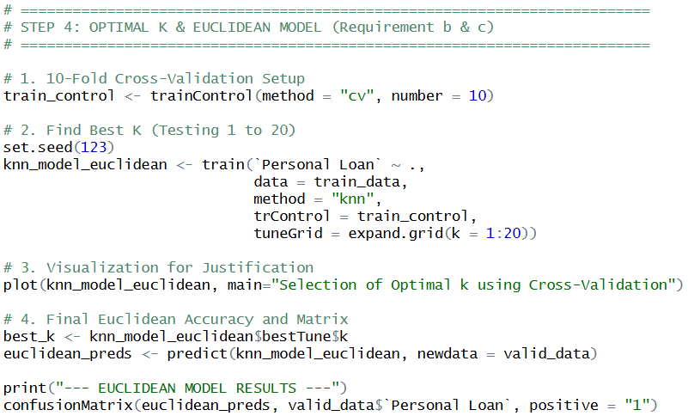

4.4 Cross-Validation Accuracy Plot
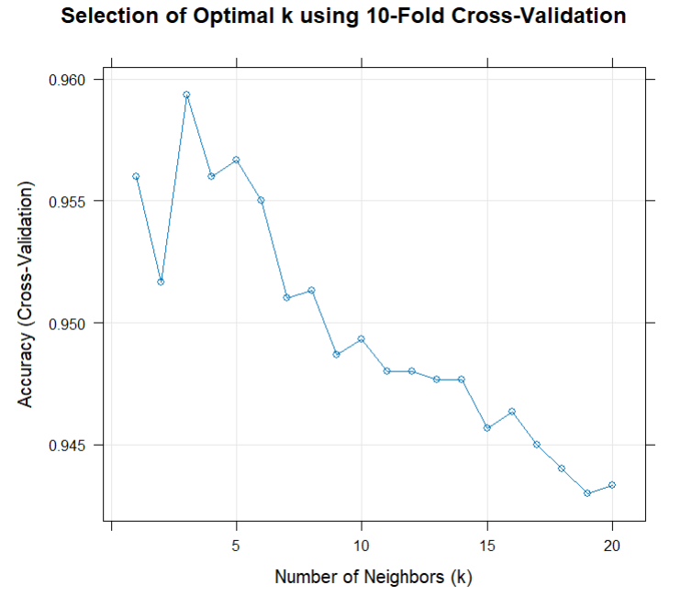

- The "Peak": The graph clearly shows that the model reaches its highest accuracy (approximately 96%) when k=3.
- Empirical Justification: By using this visualization, we can prove that k=3 is the "sweet spot".
  - If we chose a k smaller than 3, the line drops, meaning the model is becoming too sensitive to outliers (noise).
  - If we choose a k larger than 3, the accuracy steadily declines, meaning the neighborhood is being "diluted" by too many customers from the other class (non-loan takers).
- Conclusion: Therefore, we selected k=3 as the optimal parameter for our final classification based on this data-driven evidence.

5.0 Comparison of Distance Metrics
Now that we have justified k=3, we use this section to compare how the model performs using two different mathematical ways to measure "closeness".

5.1 Performance Comparison
We evaluated the model using Euclidean Distance (standard) and Weighted k-NN (Optimal Kernel) to see which would better help JB Bank expand its asset base.
Metric | Euclidean Model | Weighted Model
Overall Accuracy | 96.15% | 96.50%
Sensitivity (Recall) | 64.58% | 71.35%
Specificity | 99.50% | 99.17%

5.2 Justification of Metric Choice
While both models are highly accurate, we recommend the Weighted k-NN model for the following reasons:
- Targeting the 9.6%: Since the bank's target group (loan takers) is a small minority, maximizing Sensitivity is crucial.
- Identifying Potential: The Weighted model correctly identifies 71.35% of actual loan takers, compared to only 64.58% in the Euclidean model.
- Business Value: In marketing, a "False Negative" (missing a potential customer) is more expensive than a "False Positive". The Weighted model's ability to give closer neighbors more "voting power" makes it a more effective tool for JB Bank's outreach.

5.3 R Implementation: Model Comparison
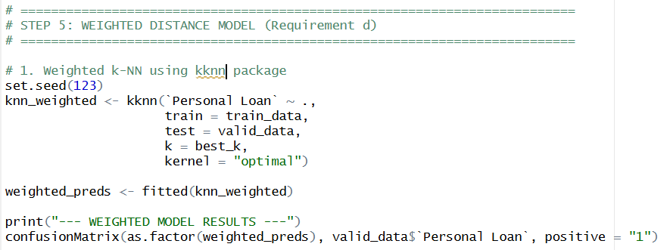

6.0 Conclusion and Algorithm Discussion

6.1 Summary of Findings
The k-Nearest Neighbors (k-NN) model developed in this study demonstrates a high level of performance in identifying customers with a high probability of accepting personal loans. Our analysis concludes that the Weighted k-NN model is the most effective strategic tool for JB Bank, achieving a peak accuracy of 96.50% and a sensitivity of 71.35%. By focusing on key drivers such as Income, Education level, and Credit Card usage (CCAvg), the bank can implement a precision-targeted marketing strategy that yields a higher return on investment than general outreach.

6.2 Pros and Cons of the k-NN Algorithm
As per the assignment requirements, we have evaluated the strengths and limitations of the chosen algorithm:
Pros:
- Simplicity and Interpretability: k-NN is easy to implement and does not require complex model training or high-level parameter tuning.
- Efficiency in Pattern Recognition: It is highly effective at capturing non-linear patterns in structured financial data, making it suitable for classification tasks like loan prediction.
- Intuitive Presentation: The results are easily understood by business stakeholders, which helps in building confidence in data-driven strategies.
Cons:
- The "Lazy Learner" Problem: k-NN does not build a generalized model; instead, it uses the entire dataset for every prediction.
- Computational Overhead: As JB Bank’s customer base grows into the millions, the computational cost of finding neighbors increases significantly, potentially requiring higher-end computing facilities or optimization techniques.
- Sensitivity to Data Quality: The model's performance relies heavily on proper normalization and the removal of redundant predictors, as it is highly sensitive to the scale and noise of the data.

6.3 Final Recommendation
Altogether, it is suggested that JB Bank implement this k-NN model in its future marketing campaigns to target customers classified as "1" (Potential Acceptors). This targeted approach will allow the bank to optimize resource allocation, achieve higher conversion rates, and gain deeper insights into customer financial behavior.

7.0 Team Contribution
MATRIC NUMBER | NAME | CONTRIBUTION
22012176 | MUHAMMAD FIRMAN HAKIM BIN CHE RAMLEE | Assisted in coding the classification model and data preprocessing.
22011102 | NUR FATHIAH AISHA BINTI RAMNIZA | Developed and implemented the k-NN model using R programming language.
22010844 | EIASHIA CALIANA BINTI ZURAYUSMADY | Contributed to writing the report and explaining the analysis results.
22011687 | NUR SHALILI AMIRA BINTI BADRUL HISHAM | Contributed to writing the report and preparing visualizations.
22011842 | NURDINI HUMAIRA BINTI SYAMSUL AMIR | Contributed to writing the report and discussing the model output.
22011757 | NUR IZZATI BINTI ISMAIL | Implemented the Weighted k-NN algorithm and tested the model on validation data.

